Amy Nestingen

DSC 640

10/7/2020

Week 5 and 6 Exercise: Tree Map, Area Charts, Stacked Area Charts

# R

Tree Map

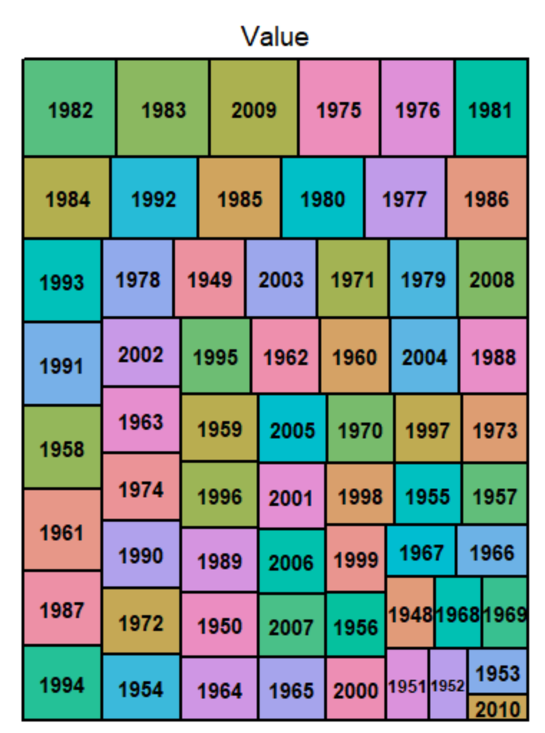

Area Chart

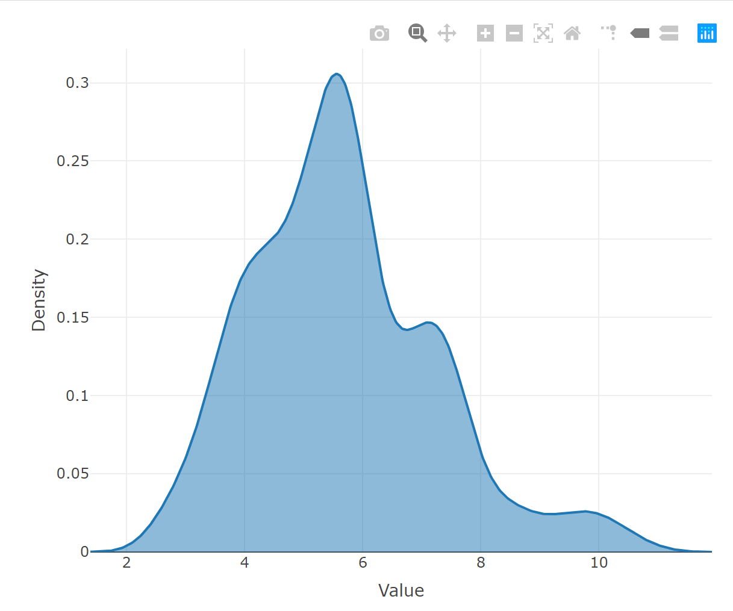

Stacked Area Chart

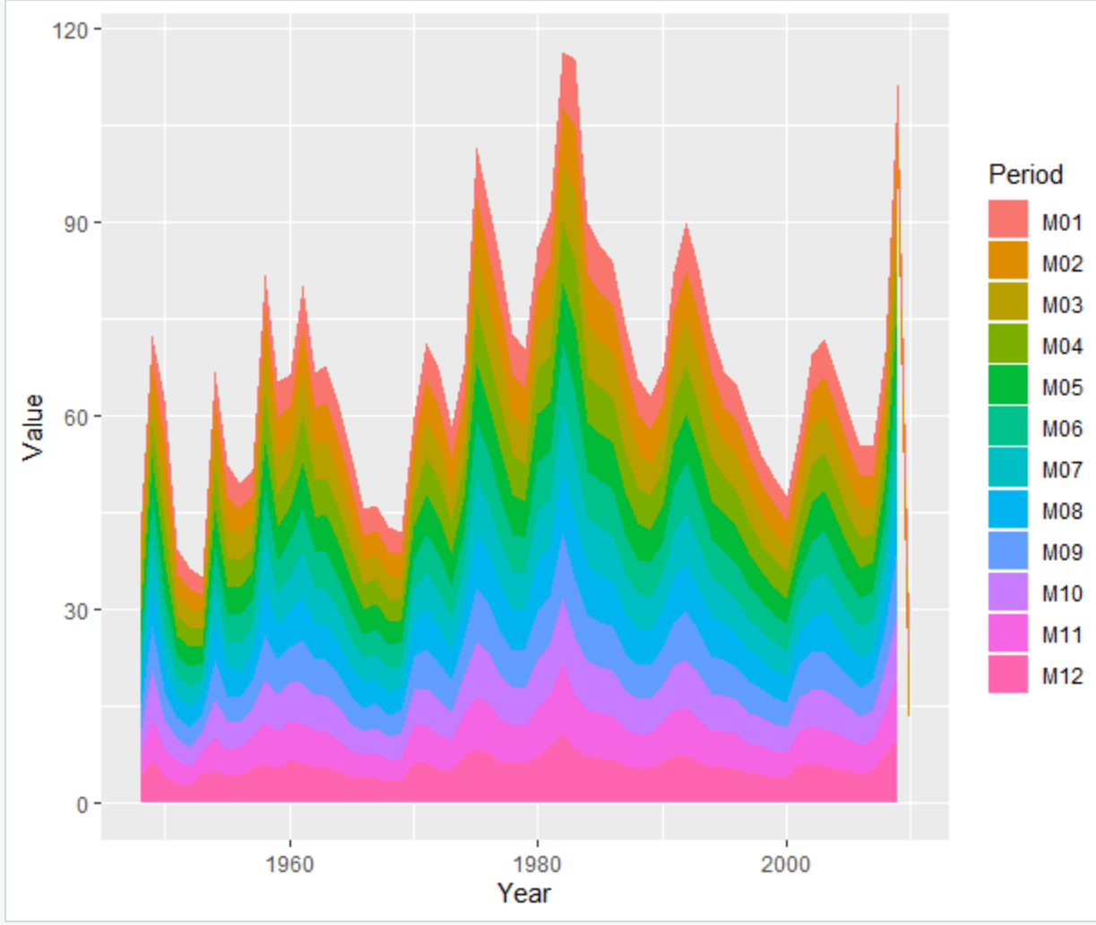

# Python

Tree Map

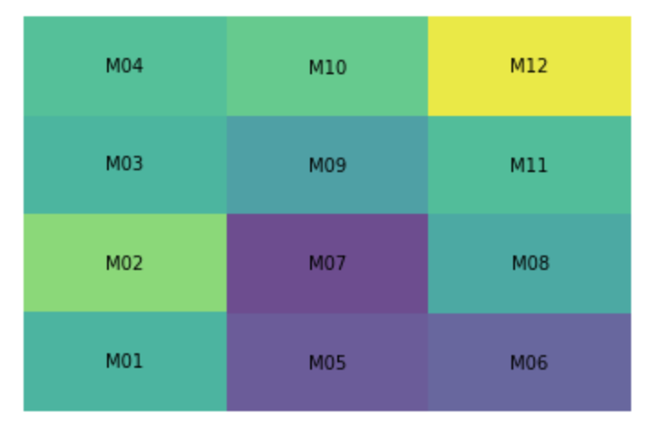

Area Chart

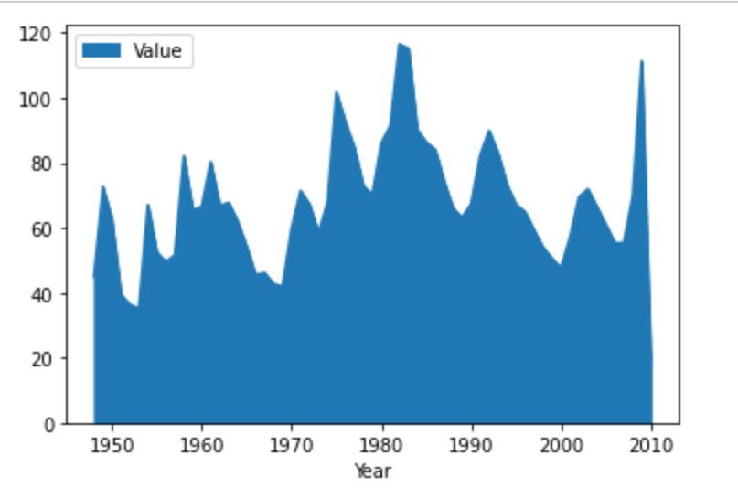

Stacked Area Chart

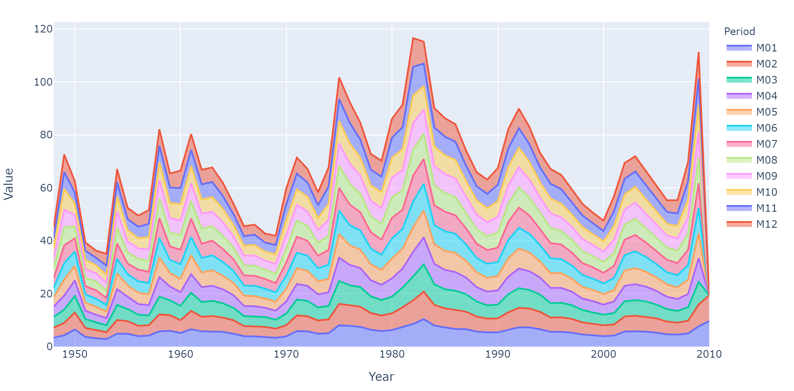

# Power BI

Tree Map

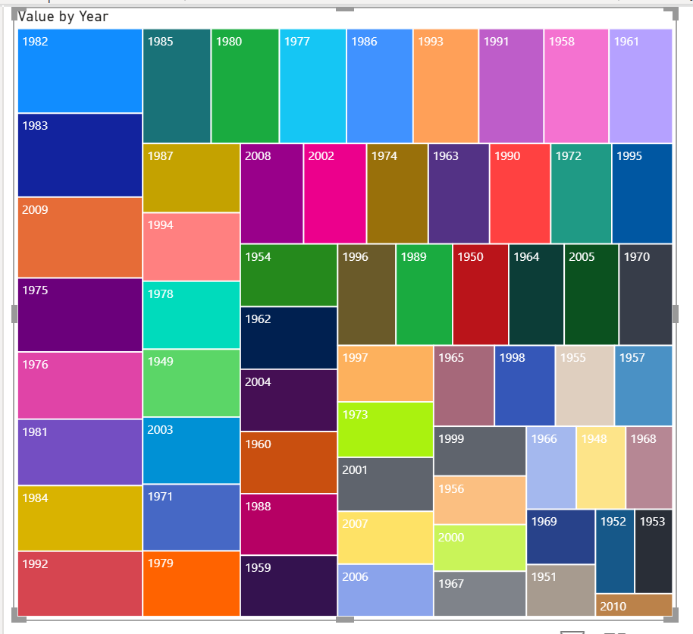

Area Chart

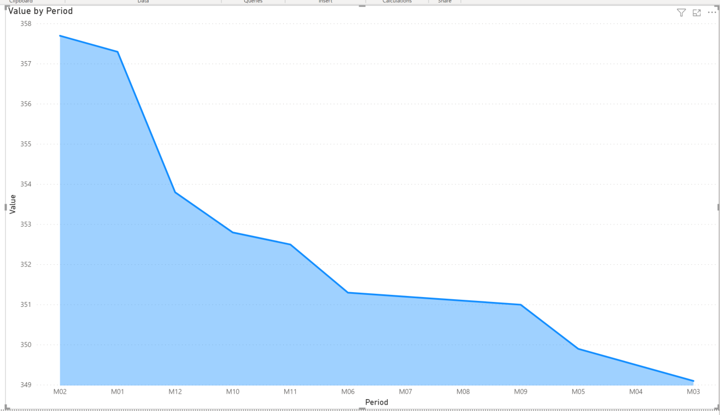

Stacked Area Chart

